**Section 2–2: Direct Variation**

Some quantities are in a relationship where the ratio of corresponding values is constant. You can write a formula for a **direct variation** function as $y=kx$, or $k=\frac{y}{x}$, where $k≠0$. *x* represents input values, and *y* represents output values. The formula $k=\frac{y}{x}$ says that, except for $(0, 0)$, the ratio of all output-input pairs equals the constant *k*, the **constant of variation**.

**Example 1: Identifying Direct Variation From Tables**

For each function, determine whether *y* varies directly with *x*. If so, what is the constant of variation and the function rule ($y=kx$)?

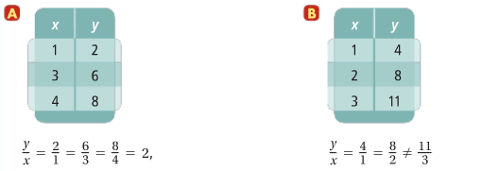

1. Since all the $\frac{y}{x}$ from the table equals to the same value, therefore, *y* varies directly with *x*. The constant of variation, *k*, is 2. The function value is $y=2x$.
2. Since all the $\frac{y}{x}$ from the table doesn’t equals to the same value (not constant), therefore, *y* does not vary directly with *x*.

**Example 2: Identifying Direct Variation From Equations**

For each function, determine whether *y* varies directly with *x*. If so, what is the constant of variation?

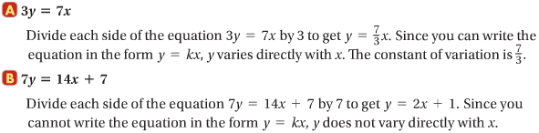

**Hint (recall):** if you rewrite the original function into $y=mx+b$ form and *b* exists, then *y* does not vary directly with *x*.

In a direct variation, $\frac{y}{x}$ is the same for all pairs of data where $x≠0$. So, $\frac{y_{1}}{x_{1}}=\frac{y_{2}}{x_{2}}$ is true for the ordered pairs $(x_{1},y_{1})$ and $(x_{2},y_{2})$, where neither $x_{1}$ nor $x_{2}$ is zero.

**direction variation: $\frac{y_{1}}{x_{1}}=\frac{y_{2}}{x_{2}}$ where $(x_{1},y_{1})$ and $(x_{2},y_{2})$**

**Example 3: Using a Proportion to Solve a Direct Variation**

Suppose *y* varies directly with *x*, and $y=9$ when $x=-15$. What is *y* when $x=21$?

$\frac{9}{-15}=\frac{y}{21}$ Write the cross products.

$9\left(21\right)=-15(y)$ Divide each side by $-15$.

$\frac{9(21)}{-15}=\frac{-15y}{-15}$ Simplify and solve.

$y=-12.6$

**Example 4: Using Direct Variation to Solve a Problem**

A salesperson’s commission varies directly with sales. For $1000 in sales, the commission is $85. What is the commission for $2300 in sales?

$Commission \left(c\right)= Percentage of Sales \left(k\right)× The Amount of Sales (s)$

Step 1: use $y=kx$ to find $k$

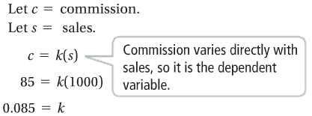

Step 2: write the direct variation for the situationa and find the commission when sales is $2300

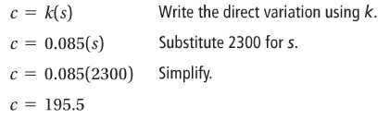

**Example 5: Graphing Direct Variation Equations**

What is the graph of each direct variation equation?

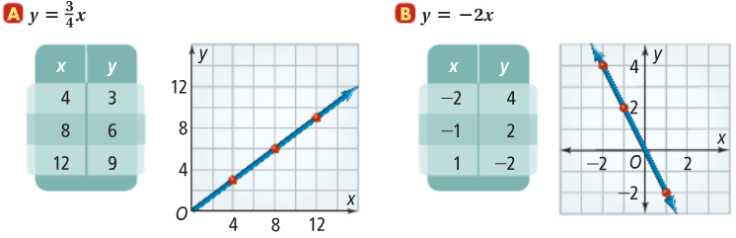

The graph of a direct variation function is **always a line through the origin**.